**We can set and access properties of objects by two ways**

1. **Using . operator**
2. **Using [ ] braces**

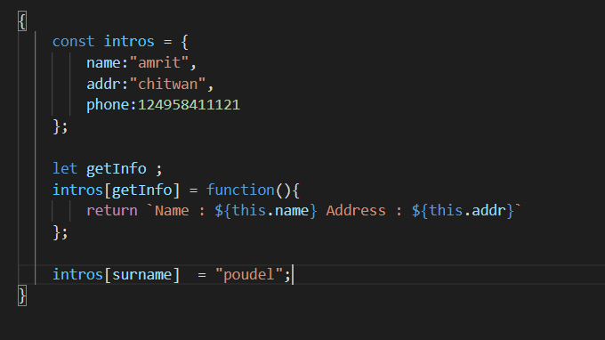

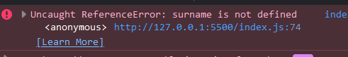

intros[surname] and intros[getInfo]

**this is a syntax mistake**

By doing this, surname and getInfo can never become keys

**But using . though solves problem**

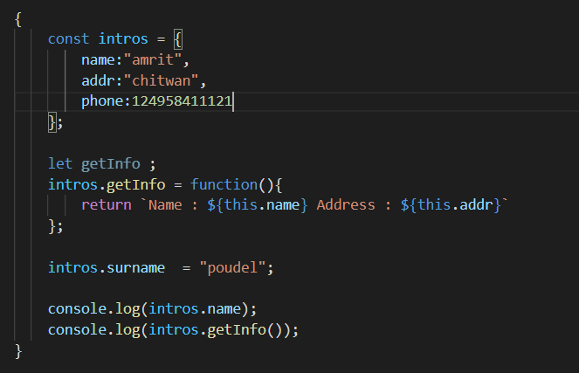

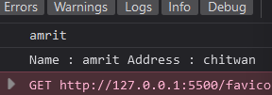

But if we want to set a property using [ ]

Rule says we must use using “ “

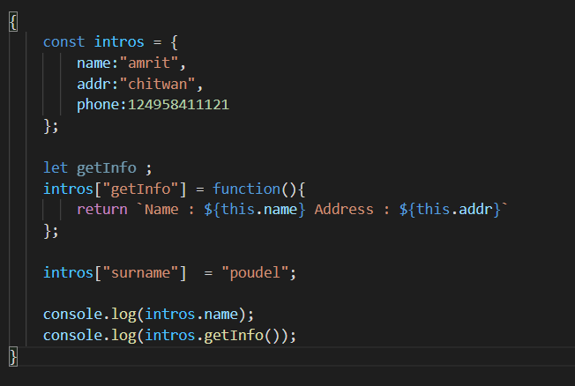

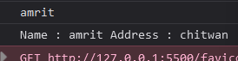

**We can also access the properties of objects using [ ]**

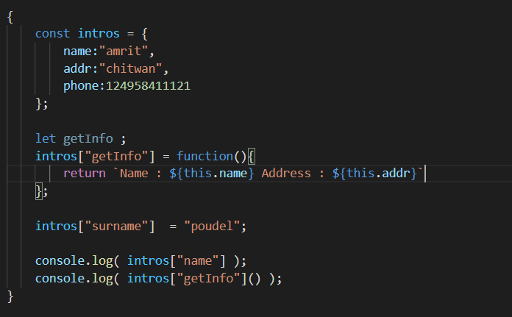

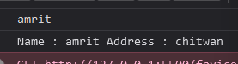

**But when we need to set the name of key separated by whitespace we cannot use . operator both to set that property in the object and to access that property**

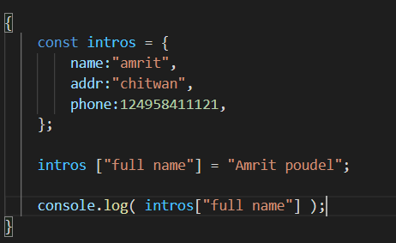



**Doing this **

**Will introduce a “full name” key value pair in the intros object**

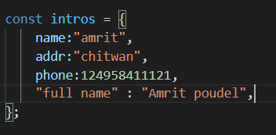

**This might be the most frequent mistake**

